**SBA5**

**Group2**

*Cucumber+ TestNG+ Selenium*

**To validate the below website depicting the selenium-webdriver and TestNG and Cucumber frameworks.**

**Register: Mercury Tours (**<http://demo.guru99.com/test/newtours/register.php>**)**

**StepDefinition:**

**package** StepDefs;

**import** org.openqa.selenium.By;

**import** org.openqa.selenium.WebDriver;

**import** org.openqa.selenium.chrome.ChromeDriver;

**import** io.cucumber.java.en.Given;

**import** io.cucumber.java.en.Then;

**import** io.cucumber.java.en.When;

**public** **class** StepDefs {

WebDriver d = **null**;

@Given("the user opens the browser")

**public** **void** the_user_opens_the_browser() {

System.*setProperty*("webdriver.chrome.driver","C:\\Users\\user\\Downloads\\chromedriver_win32\\chromedriver.exe");

d = **new** ChromeDriver();

// Write code here that turns the phrase above into concrete actions

}

@When("the user navigates to MercuryTours register page")

**public** **void** the_user_navigates_to_mercury_tours_register_page() {

d.get("http://demo.guru99.com/test/newtours/register.php");

d.getTitle().contains("Tours");

// Write code here that turns the phrase above into concrete actions

}

@Then("the user enters lands on the page")

**public** **void** the_user_enters_lands_on_the_page() {

d.findElement(By.*name*("firstName")).sendKeys("Hero ranger");

d.findElement(By.*name*("lastName")).sendKeys("Richard");

d.findElement(By.*name*("phone")).sendKeys("7530020250");

d.findElement(By.*name*("userName")).sendKeys("qwertyrockers@gmail.com");

d.findElement(By.*name*("address1")).sendKeys("qwertyqwerty hover colony");

d.findElement(By.*name*("city")).sendKeys("Persia");

d.findElement(By.*name*("state")).sendKeys("City Melbourne");

d.findElement(By.*name*("postalCode")).sendKeys("5252525");

d.findElement(By.*name*("country")).click();

d.findElement(By.*xpath*("/html/body/div[2]/table/tbody/tr/td[2]/table/tbody/tr[4]/td/table/tbody/tr/td[2]/table/tbody/tr[5]/td/form/table/tbody/tr[11]/td[2]/select/option[7]")).click();

d.findElement(By.*xpath*("//*[@id=\"email\"]")).sendKeys("rangerrathore@gmail.com");

d.findElement(By.*xpath*("/html/body/div[2]/table/tbody/tr/td[2]/table/tbody/tr[4]/td/table/tbody/tr/td[2]/table/tbody/tr[5]/td/form/table/tbody/tr[14]/td[2]/input")).sendKeys("abcd");

d.findElement(By.*xpath*("/html/body/div[2]/table/tbody/tr/td[2]/table/tbody/tr[4]/td/table/tbody/tr/td[2]/table/tbody/tr[5]/td/form/table/tbody/tr[15]/td[2]/input")).sendKeys("abcd");

d.findElement(By.*xpath*("/html/body/div[2]/table/tbody/tr/td[2]/table/tbody/tr[4]/td/table/tbody/tr/td[2]/table/tbody/tr[5]/td/form/table/tbody/tr[17]/td/input")).click();

d.findElement(By.*linkText*("Home")).click();

d.findElement(By.*name*("userName")).sendKeys("abcd");

d.findElement(By.*name*("password")).sendKeys("abcd");

d.findElement(By.*name*("submit")).click();

d.findElement(By.*linkText*("Flights")).click();

d.findElement(By.*xpath*("/html/body/div[2]/table/tbody/tr/td[2]/table/tbody/tr[4]/td/table/tbody/tr/td[2]/table/tbody/tr[5]/td/form/table/tbody/tr[2]/td[2]/b/font/input[2]")).click();

d.findElement(By.*xpath*("/html/body/div[2]/table/tbody/tr/td[2]/table/tbody/tr[4]/td/table/tbody/tr/td[2]/table/tbody/tr[5]/td/form/table/tbody/tr[3]/td[2]/b/select/option[2]")).click();

d.findElement(By.*xpath*("/html/body/div[2]/table/tbody/tr/td[2]/table/tbody/tr[4]/td/table/tbody/tr/td[2]/table/tbody/tr[5]/td/form/table/tbody/tr[4]/td[2]/select/option[5]")).click();

d.findElement(By.*xpath*("/html/body/div[2]/table/tbody/tr/td[2]/table/tbody/tr[4]/td/table/tbody/tr/td[2]/table/tbody/tr[5]/td/form/table/tbody/tr[5]/td[2]/select[1]/option[6]")).click();

d.findElement(By.*xpath*("/html/body/div[2]/table/tbody/tr/td[2]/table/tbody/tr[4]/td/table/tbody/tr/td[2]/table/tbody/tr[5]/td/form/table/tbody/tr[5]/td[2]/select[2]/option[2]")).click();

//click on the Business class

d.findElement(By.*xpath*("/html/body/div[2]/table/tbody/tr/td[2]/table/tbody/tr[4]/td/table/tbody/tr/td[2]/table/tbody/tr[5]/td/form/table/tbody/tr[9]/td[2]/font/font/input[1]")).click();

// click on Blue Skies Airlines

d.findElement(By.*xpath*("/html/body/div[2]/table/tbody/tr/td[2]/table/tbody/tr[4]/td/table/tbody/tr/td[2]/table/tbody/tr[5]/td/form/table/tbody/tr[10]/td[2]/select/option[2]")).click();

//Then click continue

d.findElement(By.*xpath*(" /html/body/div[2]/table/tbody/tr/td[2]/table/tbody/tr[4]/td/table/tbody/tr/td[2]/table/tbody/tr[5]/td/form/table/tbody/tr[14]/td/input")).click();

}

}

**StepRunner:**

**package** StepDefs;

**import** io.cucumber.testng.AbstractTestNGCucumberTests;

**import** io.cucumber.testng.CucumberOptions;

@CucumberOptions(features="src/main/resources/Features/MercuryTours.feature",glue= {"StepDefs"},

monochrome=**true**)

**public** **class** StepRunner **extends** AbstractTestNGCucumberTests {

}

**MercuryTours.feature:**

Feature: This test the MercuryTours website

Scenario: Test the MercuryTours register page

Given the user opens the browser

When the user navigates to MercuryTours register page

Then the user enters lands on the page

**Pom.xml**

<project xmlns=*"http://maven.apache.org/POM/4.0.0"* xmlns:xsi=*"http://www.w3.org/2001/XMLSchema-instance"* xsi:schemaLocation=*"http://maven.apache.org/POM/4.0.0 https://maven.apache.org/xsd/maven-4.0.0.xsd"*>

<modelVersion>4.0.0</modelVersion>

<groupId>Cucumber_TestNG</groupId>

<artifactId>Cucumber_TestNG</artifactId>

<version>0.0.1-SNAPSHOT</version>

<dependencies>

<dependency>

<groupId>io.cucumber</groupId>

<artifactId>cucumber-java</artifactId>

<version>7.0.0</version>

</dependency>

<dependency>

<groupId>io.cucumber</groupId>

<artifactId>cucumber-testng</artifactId>

<version>7.0.0</version>

</dependency>

<dependency>

<groupId>org.testng</groupId>

<artifactId>testng</artifactId>

<version>7.4.0</version>

<scope>test</scope>

</dependency>

<dependency>

<groupId>org.seleniumhq.selenium</groupId>

<artifactId>selenium-api</artifactId>

<version>3.4.0</version>

<scope>test</scope>

</dependency>

<dependency>

<groupId>org.seleniumhq.selenium</groupId>

<artifactId>selenium-ie-driver</artifactId>

<version>3.4.0</version>

<scope>test</scope>

</dependency>

<dependency>

<groupId>org.seleniumhq.selenium</groupId>

<artifactId>selenium-chrome-driver</artifactId>

<version>3.4.0</version>

</dependency>

</dependencies>

</project>

**TestCases:**

**REGISTER PAGE:**

d.findElement(By.*name*("firstName")).sendKeys("Hero ranger");

d.findElement(By.*name*("lastName")).sendKeys("Richard"); d.findElement(By.*name*("phone")).sendKeys("7530020250");

d.findElement(By.*name*("userName")).sendKeys("qwertyrockers@gmail.com");

d.findElement(By.*name*("address1")).sendKeys("qwertyqwerty hover colony");

d.findElement(By.*name*("city")).sendKeys("Persia");

d.findElement(By.*name*("state")).sendKeys("City Melbourne");

d.findElement(By.*name*("postalCode")).sendKeys("5252525");

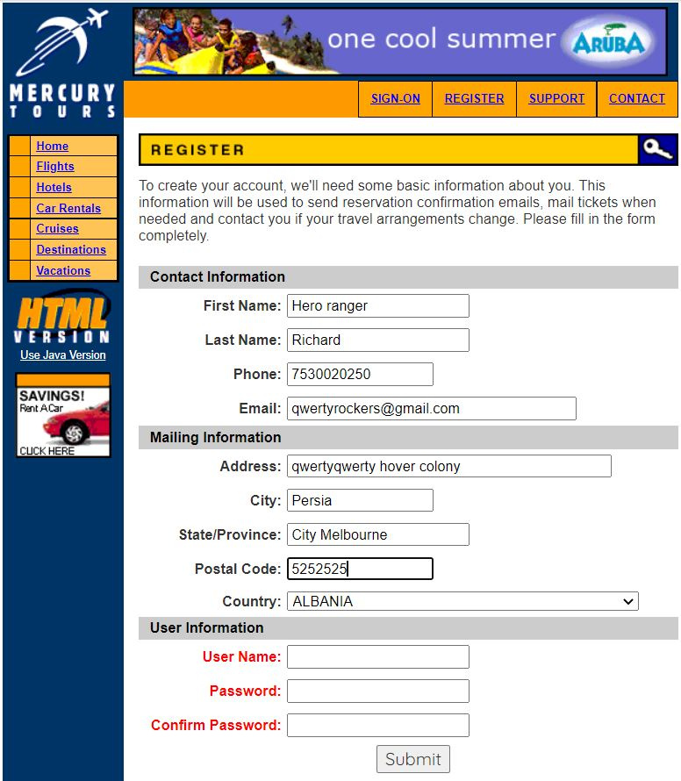

d.findElement(By.*name*("country")).click();

d.findElement(By.*xpath*("/html/body/div[2]/table/tbody/tr/td[2]/table/tbody/tr[4]/td/table/tbody/tr/td[2]/table/tbody/tr[5]/td/form/table/tbody/tr[11]/td[2]/select/option[108]")).click();

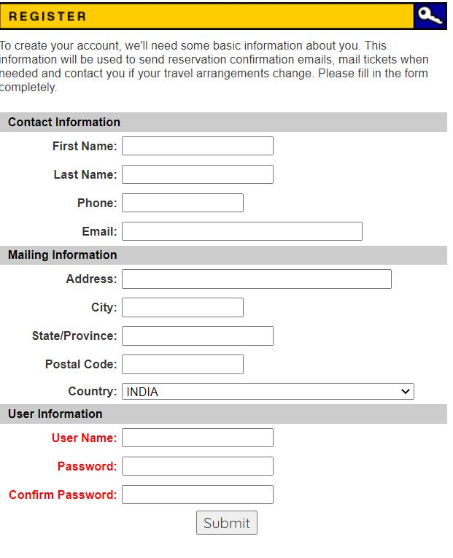

d.findElement(By.*xpath*("//*[@id=\"email\"]")).sendKeys("rangerrathore@gmail.com");

d.findElement(By.*xpath*("/html/body/div[2]/table/tbody/tr/td[2]/table/tbody/tr[4]/td/table/tbody/tr/td[2]/table/tbody/tr[5]/td/form/table/tbody/tr[14]/td[2]/input")).sendKeys("abcd");

d.findElement(By.*xpath*("/html/body/div[2]/table/tbody/tr/td[2]/table/tbody/tr[4]/td/table/tbody/tr/td[2]/table/tbody/tr[5]/td/form/table/tbody/tr[15]/td[2]/input")).sendKeys("abcd");

}

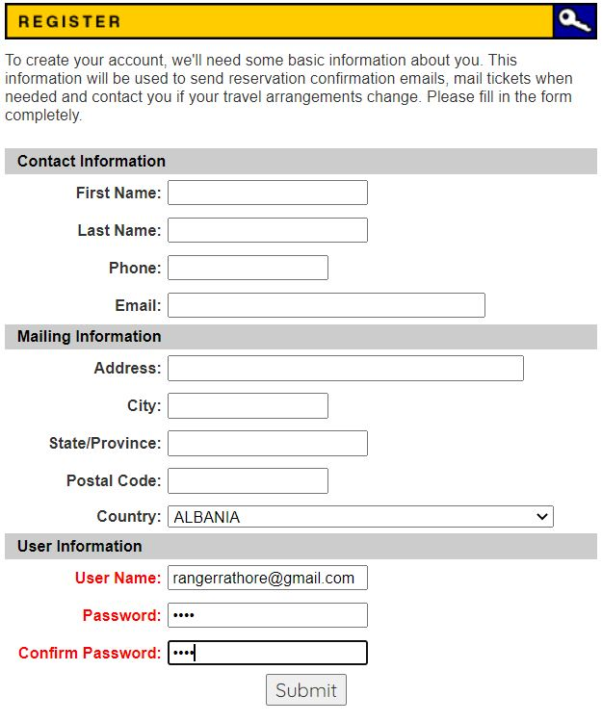

d.findElement(By.*xpath*("//*[@id=\"email\"]")).sendKeys("rangerrathore@gmail.com");

d.findElement(By.*xpath*("/html/body/div[2]/table/tbody/tr/td[2]/table/tbody/tr[4]/td/table/tbody/tr/td[2]/table/tbody/tr[5]/td/form/table/tbody/tr[14]/td[2]/input")).sendKeys("abcd");

d.findElement(By.*xpath*("/html/body/div[2]/table/tbody/tr/td[2]/table/tbody/tr[4]/td/table/tbody/tr/td[2]/table/tbody/tr[5]/td/form/table/tbody/tr[15]/td[2]/input")).sendKeys("abcd");

d.findElement(By.*xpath*("/html/body/div[2]/table/tbody/tr/td[2]/table/tbody/tr[4]/td/table/tbody/tr/td[2]/table/tbody/tr[5]/td/form/table/tbody/tr[17]/td/input")).click();

}

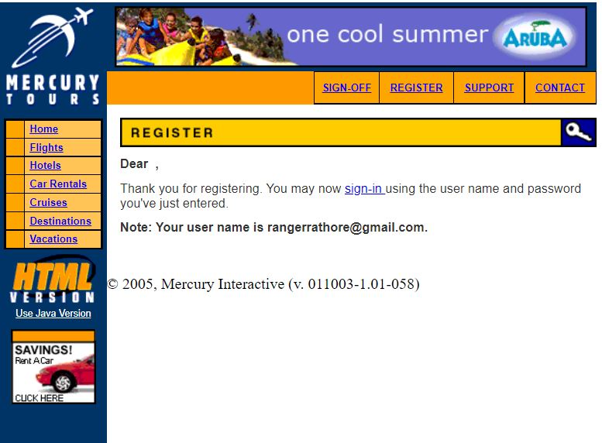

**HOME:**

d.findElement(By.*linkText*("Home")).click();

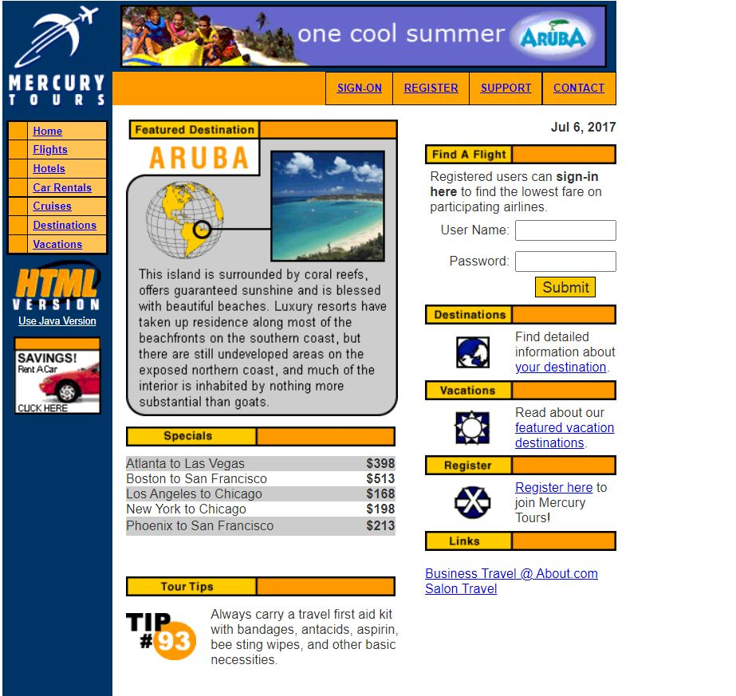

d.findElement(By.*linkText*("Home")).click();

d.findElement(By.*name*("userName")).sendKeys("abcd");

d.findElement(By.*name*("password")).sendKeys("abcd");

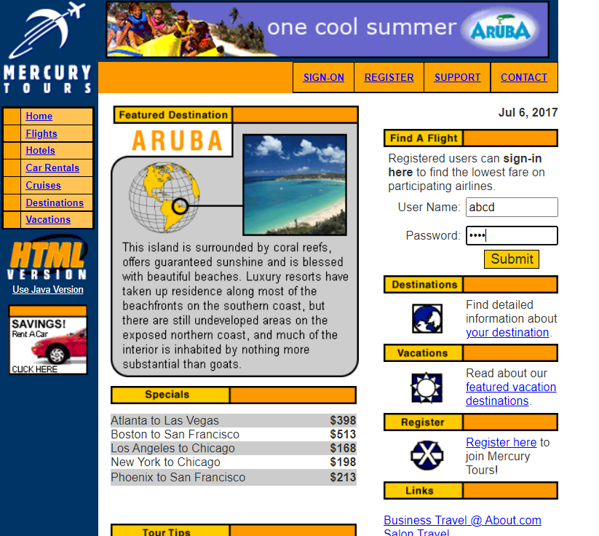

d.findElement(By.linkText("Home")).click();

d.findElement(By.name("userName")).sendKeys("abcd");

d.findElement(By.name("password")).sendKeys("abcd");

d.findElement(By.name("submit")).click();

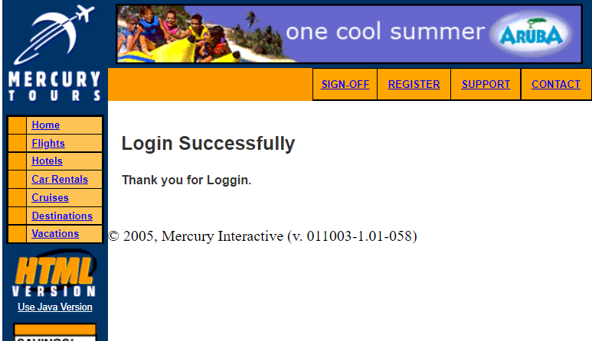

**FLIGHT PAGE:**

d.findElement(By.linkText("Flights")).click();

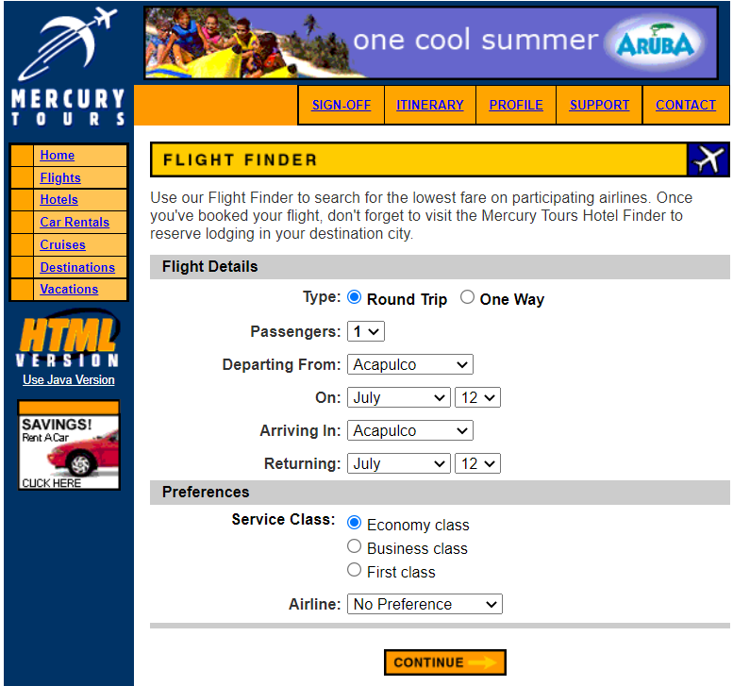

d.findElement(By.*linkText*("Flights")).click();

d.findElement(By.*xpath*("/html/body/div[2]/table/tbody/tr/td[2]/table/tbody/tr[4]/td/table/tbody/tr/td[2]/table/tbody/tr[5]/td/form/table/tbody/tr[2]/td[2]/b/font/input[2]")).click();

d.findElement(By.*xpath*("/html/body/div[2]/table/tbody/tr/td[2]/table/tbody/tr[4]/td/table/tbody/tr/td[2]/table/tbody/tr[5]/td/form/table/tbody/tr[3]/td[2]/b/select/option[2]")).click();

d.findElement(By.*xpath*("/html/body/div[2]/table/tbody/tr/td[2]/table/tbody/tr[4]/td/table/tbody/tr/td[2]/table/tbody/tr[5]/td/form/table/tbody/tr[4]/td[2]/select/option[5]")).click();

d.findElement(By.*xpath*("/html/body/div[2]/table/tbody/tr/td[2]/table/tbody/tr[4]/td/table/tbody/tr/td[2]/table/tbody/tr[5]/td/form/table/tbody/tr[5]/td[2]/select[1]/option[6]")).click();

d.findElement(By.*xpath*("/html/body/div[2]/table/tbody/tr/td[2]/table/tbody/tr[4]/td/table/tbody/tr/td[2]/table/tbody/tr[5]/td/form/table/tbody/tr[5]/td[2]/select[2]/option[2]")).click();

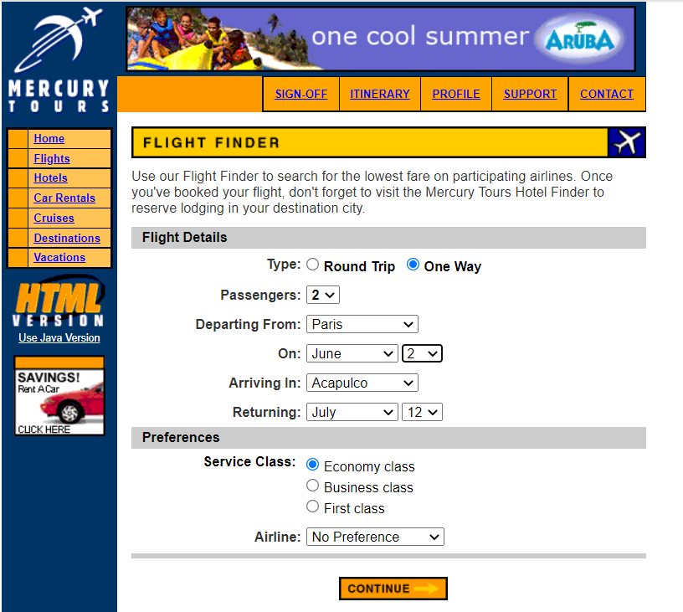

**//Preferences: click on the Business class**

d.findElement(By.xpath("/html/body/div[2]/table/tbody/tr/td[2]/table/tbody/tr[4]/td/table/tbody/tr/td[2]/table/tbody/tr[5]/td/form/table/tbody/tr[9]/td[2]/font/font/input[1]")).click();

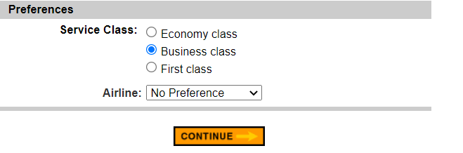

**// click on Blue Skies Airlines**

d.findElement(By.xpath("/html/body/div[2]/table/tbody/tr/td[2]/table/tbody/tr[4]/td/table/tbody/tr/td[2]/table/tbody/tr[5]/td/form/table/tbody/tr[10]/td[2]/select/option[2]")).click();

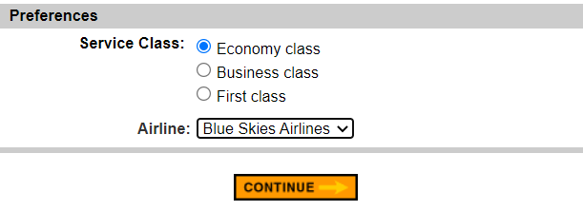

**//Then click continue**

**s**

d.findElement(By.*xpath*(" /html/body/div[2]/table/tbody/tr/td[2]/table/tbody/tr[4]/td/table/tbody/tr/td[2]/table/tbody/tr[5]/td/form/table/tbody/tr[14]/td/input")).click();

